STEP 1:VPC CREATION
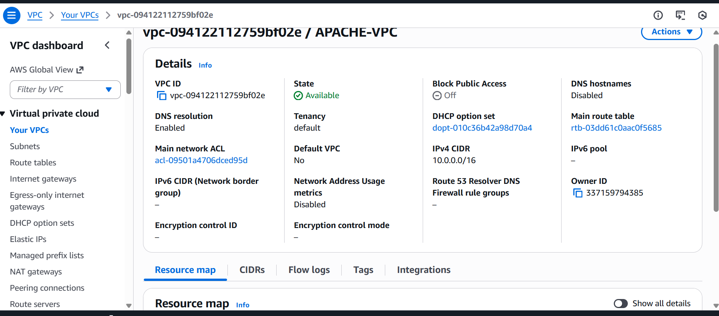
SUBNET :
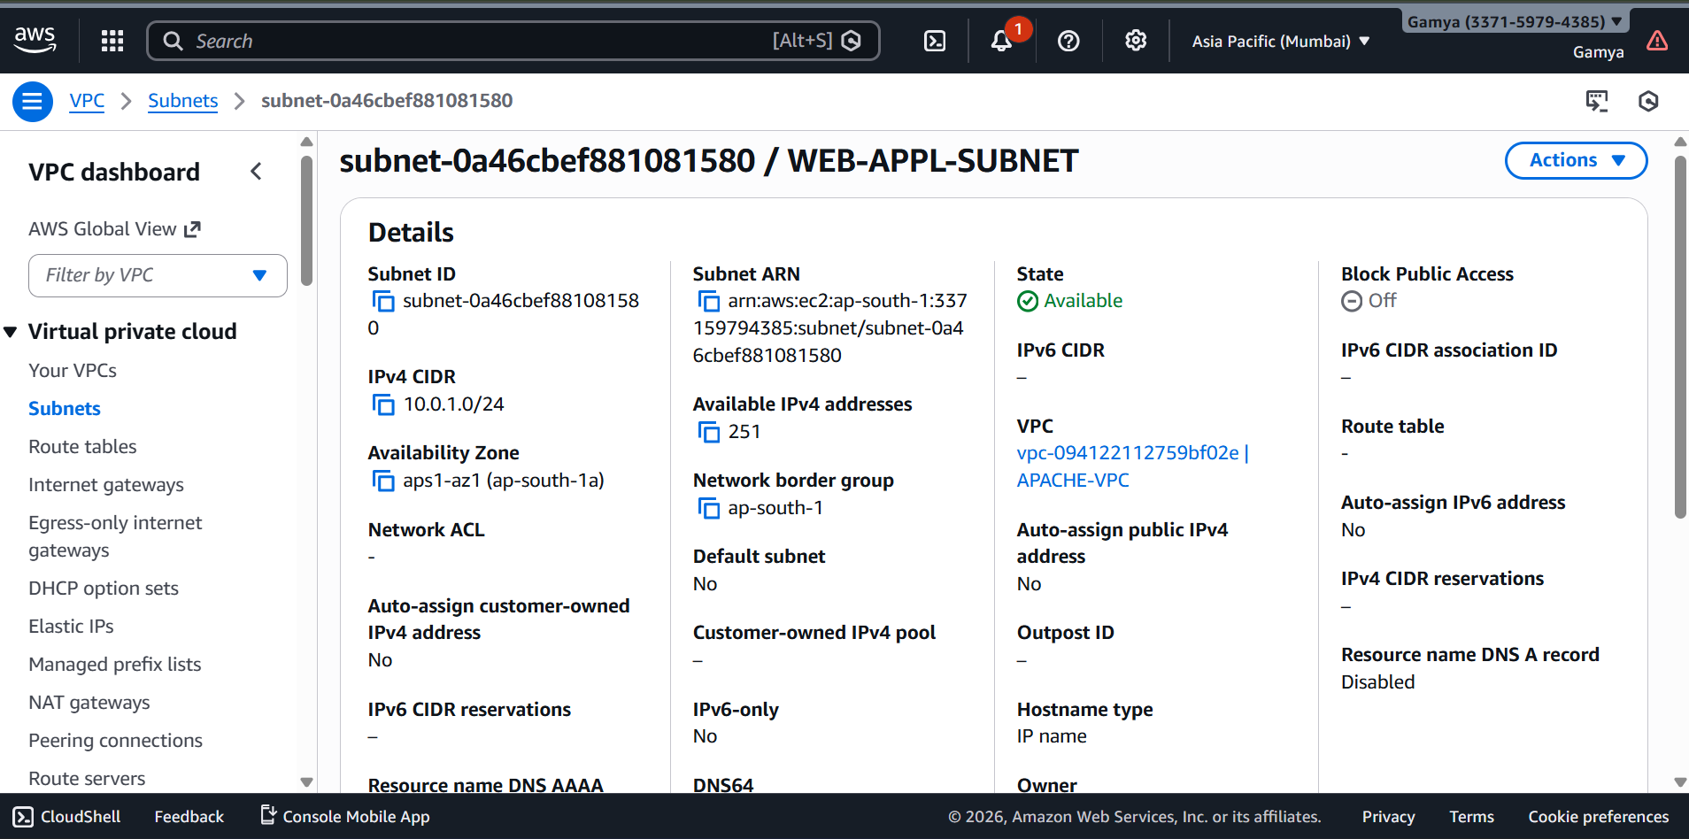
INTERNET GATEWAY ATTACHED
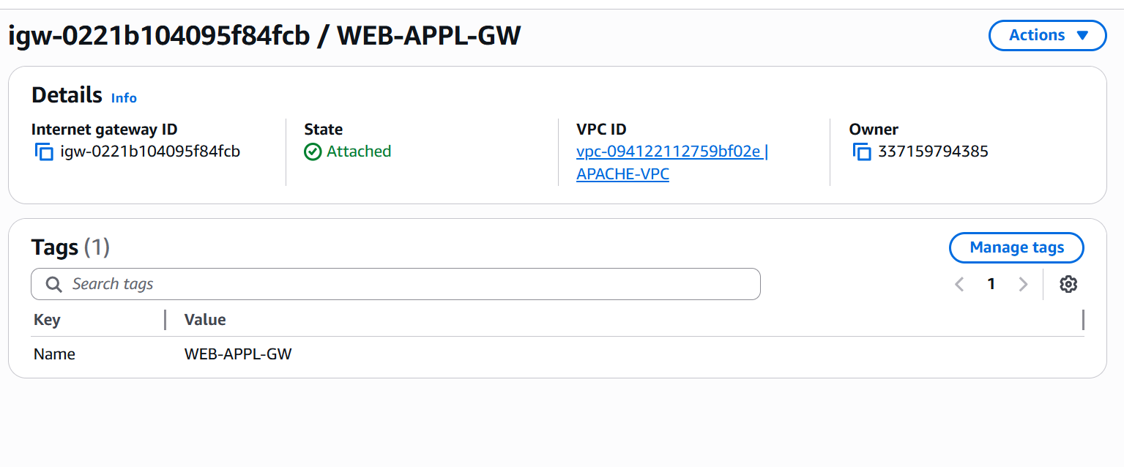
STEP 2 : Create S3 Bucket for Media Content
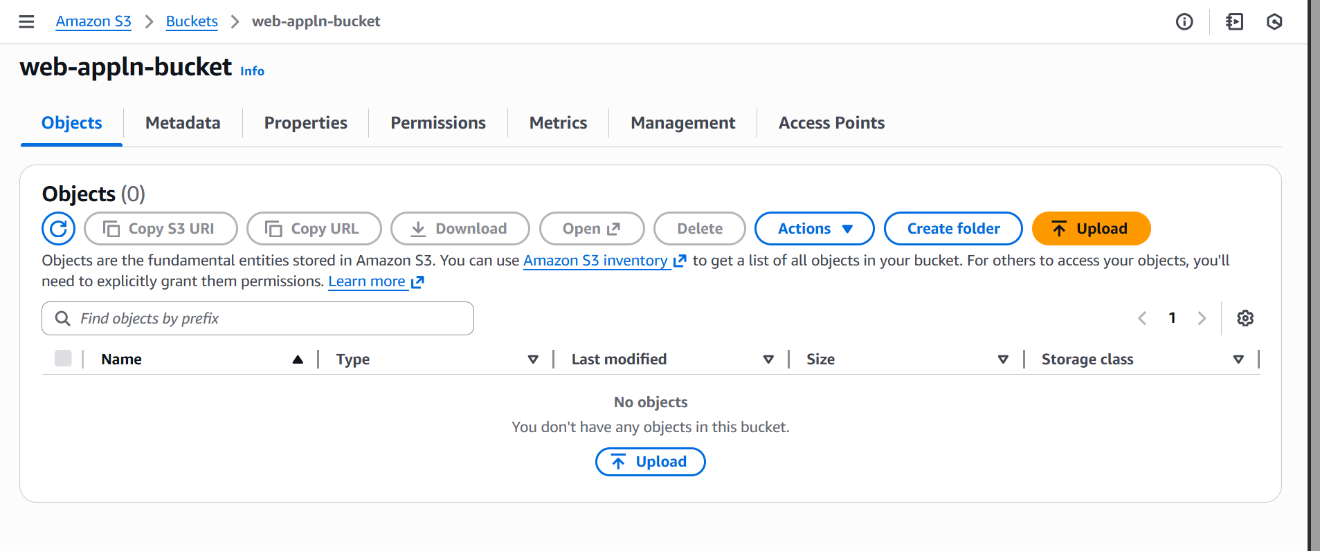
Step 3 Upload Static Media (Images & Videos)
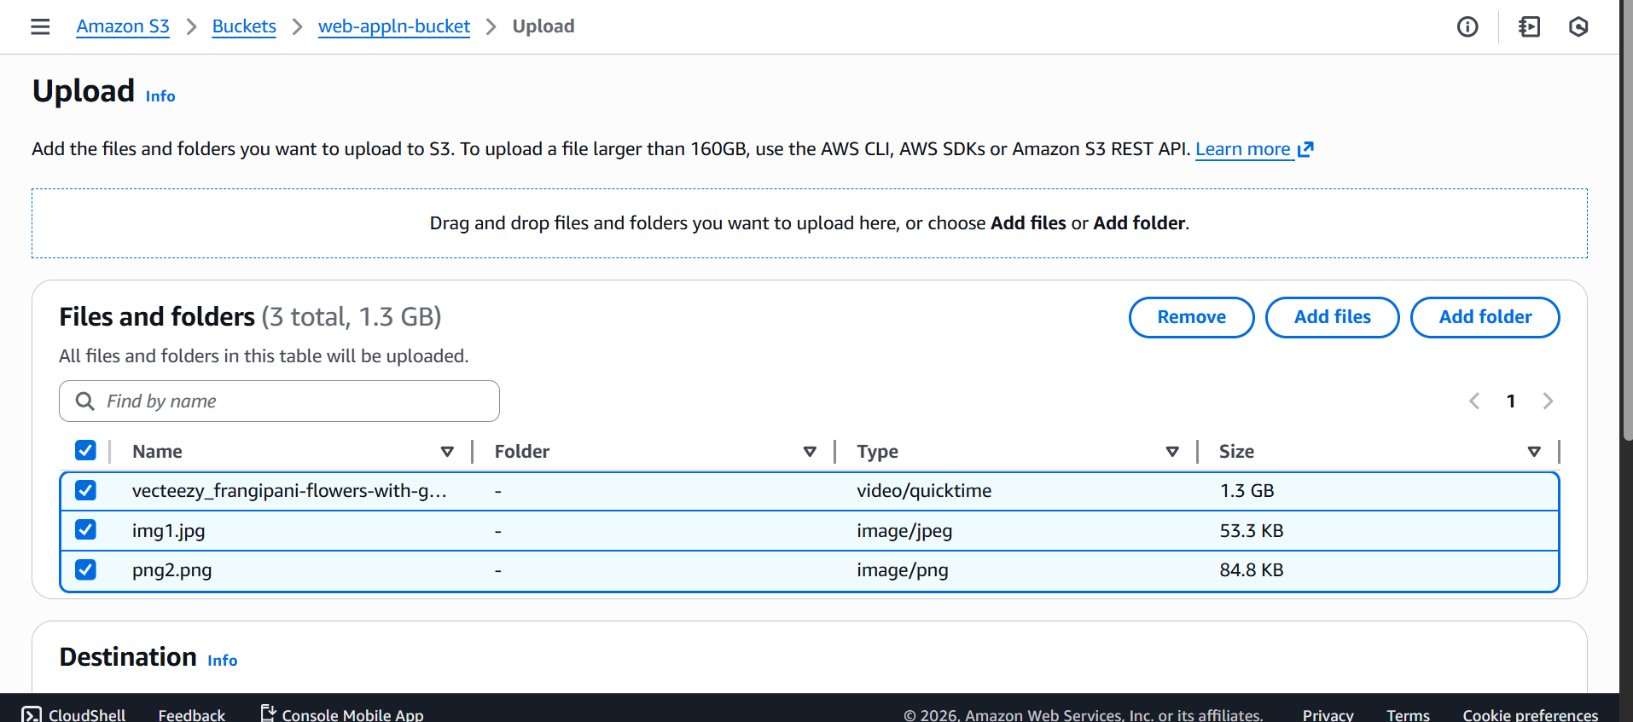
Step 4: Apply S3 Bucket Policy (Public Read)
